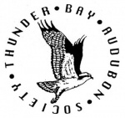

1965 2015

50th Anniversary Celebration
You are cordially invited to attend the Thunder Bay Audubon Society’s 50th Anniversary Celebration
October 13, 2015
Besser Museum for Northeast Michigan
(Handicapped accessible)
491 Johnson Street, Alpena

5:00 Self-guided Museum Tour (optional)
6:00 Welcome & Hors d’oeuvres
7:00 Program
- Jonathan E. Lutz, Executive Director of Michigan Audubon Society
- Sergej Postupalsky, Wildlife biologist/Osprey researcher
- PowerPoint presentation of the last 50 years

Cost: $12 per person, payable at door. Please RSVP by October 1st to Linda lklemens@ymail.com or Karen 989-595-3585

